Assignment

Stage One Submission

2805ICT/3815ICT/7805ICT

Group Number: GP13

Student name: Kyle Kent Student ID: s5182050 Enrolled Course Code: 2805ICT

# Table of Contents

Table of Contents 2

1.0 Project Planning and Documentation 3

1.1 Time Schedule 3

1.2 Total working hours 3

1.3 Effort and contribution table 3

1.4 Version Control System 4

2.0 Requirements Analysis 4

2.1 Functional requirements 4

2.2 Non-functional requirements 4

2.3 Use case diagram 4

2.4 Full use case description 4

2.5 Requirement - use case traceability matrix 4

2.6 Activity diagram 4

3.0 Video link 5

# 1.0 Project Planning and Documentation

## 1.1 Time Schedule

This table should reflect who did what, how long you expected sections to take and the actual hours it took to perform the tasks.

|  |  |  |  |  |  |  |  |  |  |  |  |
| --- | --- | --- | --- | --- | --- | --- | --- | --- | --- | --- | --- |
| **Task** | | **Plan** | | | | | | **Actual** | | | |
| # | Task Name | Student | Planed Time | | Cumulative  Time | Finished Date | Time | | Cumulative Time | Finished Date |
| 1 | Project plan | Kyle Kent | | 2 hrs | 2 hrs | 25/08/2022 | 1 hr | | 1 hr | 25/08/2022 |
| 2 | Identify Functional Requirement | Kyle Kent | | 2 hrs | 2 hrs | 25/08/2022 | 1 hr | | 1 hr | 25/08/2022 |
| 3 | Identify Non-Functional Requirement | Kyle Kent | | 2 hrs | 2 hrs | 25/08/2022 | 30 mins | | 30 mins | 25/08/2022 |
| 4 | Create Use Case Diagram | Kyle Kent | | 2 hrs | 2 hrs | 25/08/2022 | 1 hr | | 1 hr | 25/08/2022 |
| 5 | Full use Case Description | Kyle Kent | | 2 hrs | 2 hrs | 25/08/2022 | 1 hr | | 1 hr | 25/08/2022 |
| 6 | Requirement Use Case Traceability Matrix | Kyle Kent | | 2 hrs | 2 hrs | 25/08/2022 | 1 hr | | 1 hr | 25/08/2022 |
| 7 | Activity Diagram | Kyle Kent | | 2 hrs | 2 hrs | 25/08/2022 | 1 hr | | 1 hr | 25/08/2022 |
| 8 | Develop StartupPage | Kyle Kent | | 3 hrs | 3 hrs | 25/08/2022 | 1 hr | | 1 hr | 25/08/2022 |
| 9 | Develop Top Score Page | Kyle Kent | | 3 hrs | 3 hrs | 28/08/2022 | 1 hr | | 1 hr | 28/08/2022 |
| 10 | Develop Configure Page | Kyle Kent | | 3 hrs | 3 hrs | 28/08/2022 | 1 hr | | 1 hr | 28/08/2022 |
| 11 | Develop Game Page | Kyle Kent | | 3 hrs | 3 hrs | 28/08/2022 | 1 hr | | 1 hr | 28/08/2022 |
| 12 | Develop Game Environment | Kyle Kent | | 4 hrs | 4 hrs | 28/08/2022 | 8 hrs | | 8 hrs | 28/08/2022 |
| 13 | Develop AI | Kyle Kent | | 2 hrs | 2 hrs | 28/08/2022 |  | |  | 28/08/2022 |
| 14 | Develop code Integration | Kyle Kent | | 3 hrs | 3 hrs | 28/08/2022 | 4 hrs | | 4 hrs | 28/08/2022 |
| 15 | Github Version Control Management | Kyle Kent | | Consecutive | Consecutive | 25/08/2022 | Consecutive | | Consecutive | Ongoing |

## 1.2 Total working hours

|  |  |  |
| --- | --- | --- |
| **Student Name (#ID)** | **Plan (hours)** | **Actual (hours)** |
| **Kyle Kent (s5182050)** | 40 | 22.5 |
|  |  |  |
|  |  |  |
|  |  |  |
| **Total working hours** | 40 |  |
| **Average working hours per person** | 40 |  |

## 1.3 Effort and contribution table

|  |  |  |  |
| --- | --- | --- | --- |
| **Student** | **Effort Level\***  (Rating from 0 – 5, the information is filled by the group) | **Contribution Level\***  (Rating from 0 – 5, the information is filled by the group) | **Justification**  If a student received level rating of 3 or less, your group need to give explanation for the low level rating |
| **Kyle Kent (s5182050)** | 5 | 5 |  |
| **Total** | 5 | 5 |  |

* *Level ratings, 5 = excellent, 4 = good, 3 = reasonable, 2 = poor, 1 = unacceptable, 0 = none

## 1.4 Version Control System

[Your group needs to use a version control system (VCS) to manage the source code development. Please use screenshot to demonstrate that a suitable VCS system has been applied in developing this project. ]

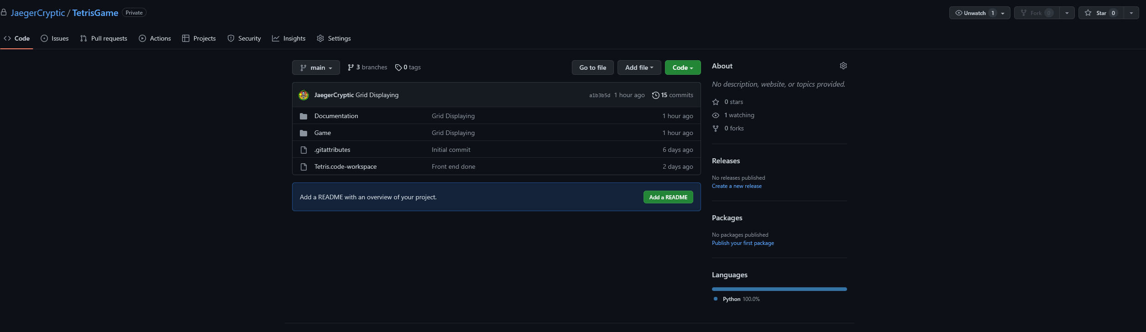

# 2.0 Requirements Analysis2.1 Functional requirements

|  |  |  |
| --- | --- | --- |
| **Identifier** | **Priority** | **Requirement** |
| F-REQ1 | 1 | The system should be executable across multiple platforms |
| F-REQ2 | 1 | The system should display the start-up page upon start up |
| F-REQ3 | 1 | The start-up page should display the title of Tetris |
| F-REQ4 | 1 | The start-up page should display the list of students in alphabetical order |
| F-REQ5 | 1 | The start-up page should display the current year and course code for this assessment |
| F-REQ6 | 1 | The start-up page should display an exit button |
| F-REQ7 | 1 | The start-up page should display a score button |
| F-REQ8 | 1 | The start-up page should display a configure button |
| F-REQ9 | 1 | The start-up page should display a play button |
| F-REQ10 | 2 | The start-up page exit button should be fully functional and upon selection by the user, termite the program successfully (return 0) |
| F-REQ11 | 3 | The score button displayed on the start-up page should fully function and upon selection by the user, redirect to the score page. Where the top 10 best scores and the users are displayed. A close button will also return the user to the start-up page |
| F-REQ12 | 3 | The configure button displayed on the start-up page should fully function and upon selection by the user, redirect to the configure page. Where you may manipulate, size of field, game level, normal or extended game and game mode. A close button will also return the user to the start-up page |
| F-REQ13 | 1 | The play button displayed on the start-up page should fully function and upon selection by the user, redirect to the play page. |
| F-REQ14 | 1 | The play page should display a game field and a dropping block |
| F-REQ15 | 1 | The dropping block shall move towards the bottom of the game field |
| F-REQ16 | 4 | The play page should display group number |
| F-REQ17 | 4 | The play page should display current score |
| F-REQ18 | 4 | The play page should display number of lines eliminated this session |
| F-REQ19 | 4 | The play page should display current level |
| F-REQ20 | 4 | The play page should display extended mode or normal mode |
| F-REQ21 | 4 | The play page should display player mode or ai mode |
| F-REQ22 | 3 | The play page should display the shape of the next dropping block when current block drops to bottom |
| F-REQ23 | 2 | On the play page, the user may manipulate the dropping block, left, right and turn (90 degrees clockwise) |
| F-REQ24 | 2 | On the play page when the user presses ESC. A prompt box will appear with yes finishing the game and returning to the start-up page and no continuing. |
| F-REQ25 | 3 | If the user completed a game within the top 10, they will be prompted to enter a username to be displayed on the score page. |
| F-REQ26 | 4 | On the play page when the user presses ‘P’ the game will pause and resume |
| F-REQ27 | 4 | On the play page when the user presses ‘M’ the game will toggle music on/off |
| F-REQ28 | 3 | The game shall feature 7 different blocks |
| F-REQ29 | 3 | The extended game shall feature 2 additional blocks |

2.2 Non-functional requirements

|  |  |  |
| --- | --- | --- |
| **Identifier** | **Priority** | **Requirement** |
| NF-REQ1 | 5 | Useability – The system aesthetically pleasing |
| NF-REQ2 | 5 | Useability – The system should be straight forward and easy to understand |
| NF-REQ3 | 5 | Compatibility – The system should not require large amounts of computer memory to play |
| NF-REQ4 | 5 | Performance – The system should function with minimal computing speed |
| NF-REQ5 | 5 | Functionality – The system should not require authorization to run |
| NF-REQ6 | 5 | Compatibility – The system should run on portable devices such as windows laptops |
| NF-REQ7 | 5 | Reliability – The system should be reliable and not reach a critical failure time under normal usage. |

## 2.3 Use case diagram

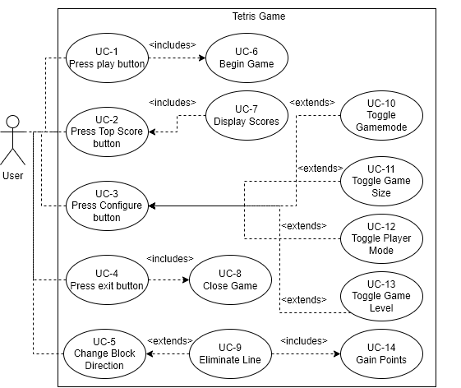

## 2.4 Full use case description

|  |  |  |
| --- | --- | --- |
| Use Case | Eliminate Line | |
| Scenario | User manipulates blocks | |
| Triggering Event | The user uses the arrow keys to rotate blocks to fill a line | |
| Brief Description | User rotates the blocks around using the arrorw keys to move it left, right and rotate 90 degrees clockwise. User will repeat this action repeatedly, resulting in a line being filled with blocks, eliminating the line and gaining points | |
| Actors | User,AI,System | |
| Related User Cases | Change Block Direction, Gain Points | |
| Stakeholders | Players, Developer | |
| Preconditions | * Line must be filled | |
| Postconditions | * Field not filled * Determine number of lines filled * Game not ended | |
| Flow of Activities | User | System |
| 1. Press play button | * 1. Set game   2. Begin game |
| 1. Press key to align block | * 1. Move block in specified direction |
| 1. User removes line | * 1. Points are scored |
| 1. User presses esc and yes | * 1. Check score   2. Terminate |
|  | 1. Screen full |
| Exception Conditions | 1. User quits game 2. User presses key that does not corepeond to the game 3. Lines filled with blocks | |

## 2.5 Requirement - use case traceability matrix

|  |  |  |  |  |  |  |  |  |  |
| --- | --- | --- | --- | --- | --- | --- | --- | --- | --- |
| Req: | UC-1 | UC-2 | UC-3 | UC-4 | UC-5 | UC-6 | UC-7 | UC-8 | UC-9 |
| F-REQ1 | X |  |  |  |  |  |  |  |  |
| F-REQ2 | X |  |  |  |  |  |  |  |  |
| F-REQ3 | X |  |  |  |  |  |  |  |  |
| F-REQ4 | X |  |  |  |  |  |  |  |  |
| F-REQ5 | X |  |  |  |  |  |  |  |  |
| F-REQ6 |  |  |  | X |  |  |  | X |  |
| F-REQ7 |  | X |  |  |  |  |  |  |  |
| F-REQ8 |  |  | X |  |  |  |  |  |  |
| F-REQ9 | X |  |  |  | X |  |  |  |  |
| F-REQ10 |  |  |  | X |  |  |  | X |  |
| F-REQ11 |  | X |  |  |  |  | X |  |  |
| F-REQ12 |  |  | X |  |  |  |  |  |  |
| F-REQ13 | X |  |  |  | X |  |  |  |  |
| F-REQ14 |  |  |  |  |  | X |  |  |  |
| F-REQ15 |  |  |  |  |  | X |  |  | X |
| F-REQ16 |  |  |  |  |  | X |  |  |  |
| F-REQ17 |  |  |  |  |  | X |  |  |  |
| F-REQ18 |  |  |  |  |  | X |  |  |  |
| F-REQ19 |  |  |  |  |  | X |  |  |  |
| F-REQ20 |  |  |  |  |  | X |  |  |  |
| F-REQ21 |  |  |  |  |  | X |  |  |  |
| F-REQ22 |  |  |  |  |  | X |  |  |  |
| F-REQ23 |  |  |  |  | X |  |  |  | X |
| F-REQ24 |  |  |  |  |  | X |  | X |  |
| F-REQ25 |  |  |  |  |  | X |  |  |  |
| F-REQ26 |  |  |  |  |  | X |  |  |  |
| F-REQ27 |  |  |  |  |  | X |  |  |  |
| F-REQ28 |  |  |  |  |  | X |  |  |  |
| F-REQ29 |  |  |  |  |  |  |  |  |  |

|  |  |  |  |  |  |
| --- | --- | --- | --- | --- | --- |
| Req: | UC-10 | UC-11 | UC-12 | UC-13 | UC-14 |
| F-REQ1 |  |  |  |  |  |
| F-REQ2 |  |  |  |  |  |
| F-REQ3 |  |  |  |  |  |
| F-REQ4 |  |  |  |  |  |
| F-REQ5 |  |  |  |  |  |
| F-REQ6 |  |  |  |  |  |
| F-REQ7 |  |  |  |  |  |
| F-REQ8 | X | X | X | X |  |
| F-REQ9 |  |  |  |  |  |
| F-REQ10 |  |  |  |  |  |
| F-REQ11 | X | X | X | X |  |
| F-REQ12 |  |  |  |  |  |
| F-REQ13 |  |  |  |  |  |
| F-REQ14 |  |  |  |  |  |
| F-REQ15 |  |  |  |  | X |
| F-REQ16 |  |  |  |  |  |
| F-REQ17 |  |  |  |  |  |
| F-REQ18 |  |  |  |  |  |
| F-REQ19 |  |  |  |  |  |
| F-REQ20 |  |  |  |  |  |
| F-REQ21 |  |  |  |  |  |
| F-REQ22 |  |  |  |  |  |
| F-REQ23 |  |  |  |  | X |
| F-REQ24 |  |  |  |  |  |
| F-REQ25 |  |  |  |  |  |
| F-REQ26 |  |  |  |  |  |
| F-REQ27 |  |  |  |  |  |
| F-REQ28 |  |  |  |  |  |
| F-REQ29 | X |  |  |  |  |

## 2.6 Activity diagram

# 3.0 Video link

[please put the URL of your video, and make sure that the video can be viewed by the assessor]